Klick lathund
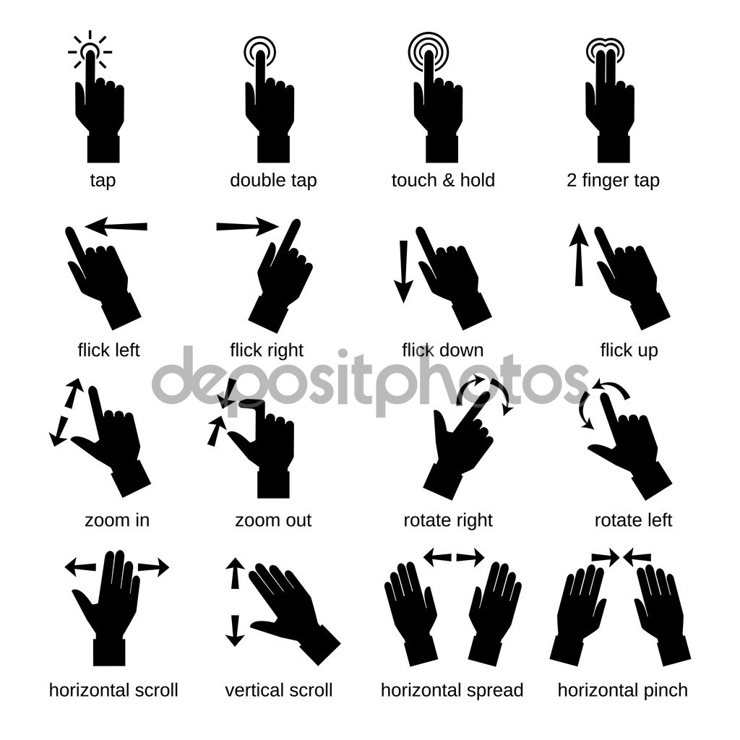
x1

= Meny

x2

= Markera gjord

x3

= Ta bort

2sek

= Redigera

